- OPINION
- COMMENTARY

Shakespeare’s Uncomfortable Message for Baby Boomers

‘King Lear’ confronts the challenges of the empty nest, retirement and facing one’s own mortality.
175 Comments
By
Paula Marantz Cohen
Oct. 26, 2018 6:54 p.m. ET
•
•
•
•
• • 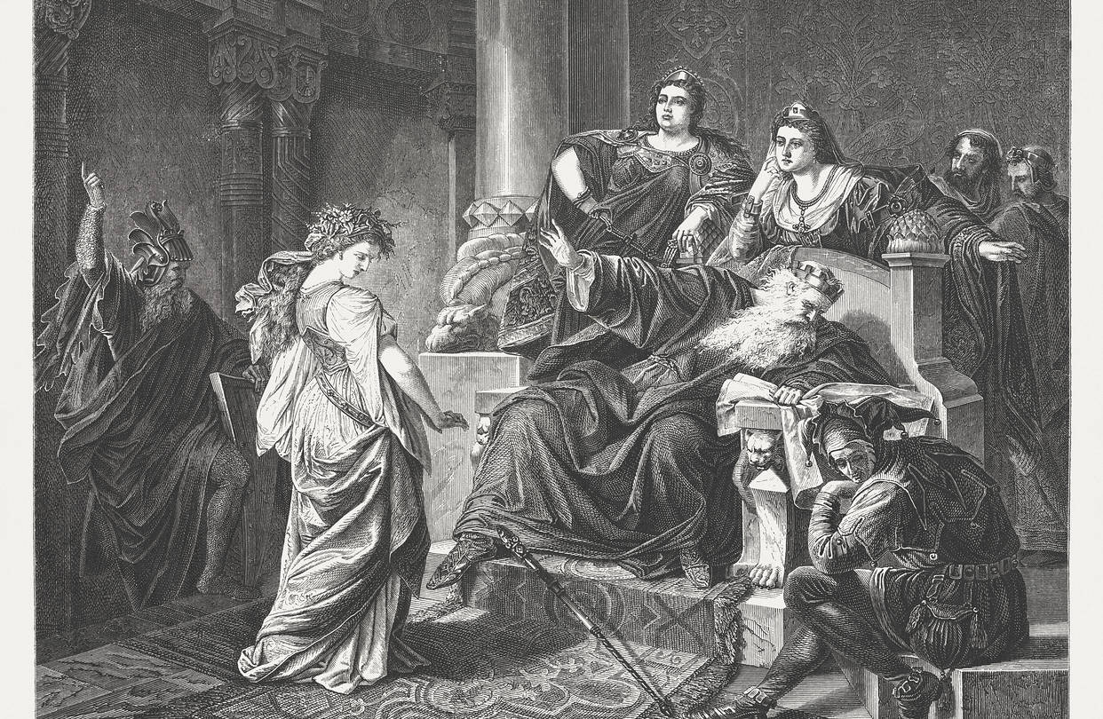
A scene from Shakespeare's “King Lear,” part of a wood engraving after a painting by August von Heckel, 1873. PHOTO: GETTY IMAGES
The scholar A.C. Bradley rendered a magisterial judgment in 1904: “King Lear” is Shakespeare’s least popular play—but also his greatest.
I’ve taught Shakespeare to college students for many years, and I can attest that “Lear” is both difficult to like and a profound work of genius. But unlike Bradley, who attributes the problem to technical issues of performance—he called the play “too huge for the stage”—I think its unpopularity is a function of demographics. Viewers and readers can fully grasp it only once they’ve passed 60, and by that point they may not like what it has to say.
In the opening scene, Lear decides to relinquish the throne and divide his kingdom among his three daughters. He asks only that each tell him how much she loves him before he bestows his gift. To my students, this scene seems ridiculous. Why would a father make such a demand of his children? Why would he want them to express their love in such a contrived way?
But for someone older, the demand makes more sense. It reflects Lear’s suspicion that his grown children no longer need him as they once did, and that their love, rooted in their childhood weakness and dependency, may have evaporated. His decision to give his daughters the kingdom could spring from a desire to win back the love he fears he has already lost.
It may seem stupid for Lear to compound his vulnerability by giving away the only leverage he has left. Yet I think most parents would find his actions understandable. It is precisely when we feel unloved that we are most in need of reassurance, and thus most likely to behave irrationally. This is also why Lear believes the false expressions of love from his eldest daughters, Goneril and Regan, while banishing his youngest, Cordelia, who truly loves him but refuses to flatter him.
Few people are as credulous as Lear or have children as exploitative as Goneril and Regan. But Cordelia strikes me as a relatable case. She was Lear’s favorite, and he felt most confident in her devotion. Yet when pushed by her father to express her love, she simply explains that she loves him “according to my bond; nor more nor less,” and that some portion of her affection will be directed to her husband once she marries. This honest response—perhaps excessively honest—sends Lear into a rage. He berates Cordelia: “Better thou hadst not been born than not to have pleased me better.”
The line must resonate for many parents who invest so much in their children only to have them fail to show sufficient gratitude or, worse, respond with resentment. This is the great aftershock of parenting, and Lear is hit by it on two fronts: first with Cordelia’s muted response, and later with his other daughters’ cruelty once they no longer need him. In the former case, Lear is smug and entitled; in the latter he is, as he says, “more sinned against than sinning.”
If “King Lear” is a lesson in the unexpected results of child-rearing, it also dramatizes the vicissitudes of retirement. It captures the existential abyss that can open when a once-solid identity begins to melt, and purpose gives way to purposelessness. Lear is deprived of his retinue and thrown out into a storm, reduced to his most elemental self—a “poor bare, forked animal.” We baby boomers, aging amid a technological landscape that changes at dizzying speed, must sympathize. We, too, face a storm that can make even the most successful among us feel lost and diminished.
Lear rages at the ingratitude of his daughters and the crumbling of his regal identity, but these are ultimately stand-ins for a greater antagonist. Now on the downward curve of life, Lear faces the reality of death. Viewers and readers of the play can grasp this only when we reach the age when death, formerly hidden by the clutter of ambition and child-rearing, reveals itself.
At that point “King Lear” counsels us to moderate our expectations and sense of entitlement with regard to our children, to accept a diminished professional identity as we age, and to be philosophical in the face of our inevitable mortality. These are profound messages but not cheerful ones, which is why “Lear” is both a great work and an unpopular one.
Ms. Cohen is a dean and English professor at Drexel University.
SHOW COMMENTS(175)

